Algebra 1: Unit 4, Lesson 4

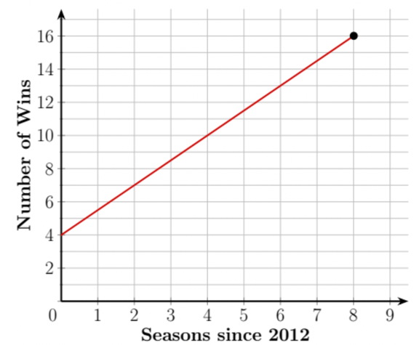
- A student uses the model $n=1.5t+4$, where $t$ is the number of seasons since $2012$ and $n$ is the number of wins, to describe a high school basketball team’s winning record over an $8$-year period. The model is shown on the graph.

What is the range of the function in inequality notation?
$$4≤y≤16$$

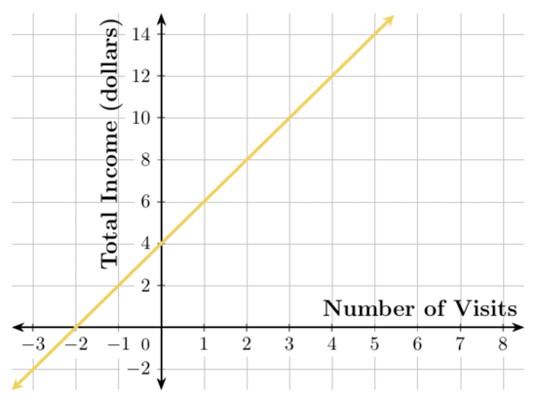
- The graph shown models the total income in relation to the number of visits to a community pool as follows:
What does the $y$-intercept represent?
The total income at 0 visits

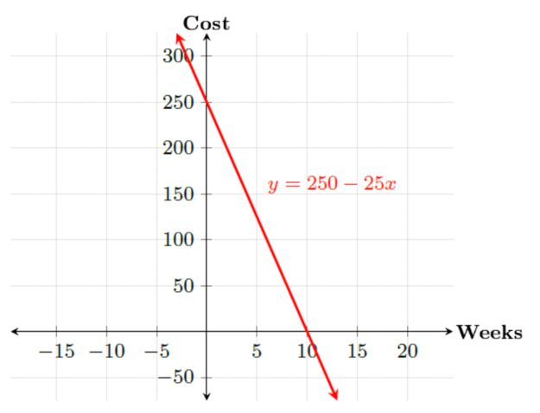
- You saved $\$250$ to spend over the summer. You decide to budget $\$25$ to spend each week. This can be modeled in the graph provided.

What is the $x$- intercept?
$$(10, 0)$$

